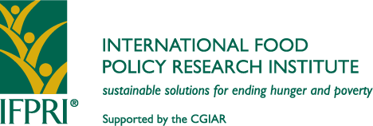 | 2033 K Street, NW  Washington, DC 20006-1002, U.S.A.  T.: 1-202-862-6496 ● F.: 1-202-467-4439  Skype ID: Shenggen.Fan  s.fan@cgiar.org ● www.ifpri.org

Supporting Country-driven Innovations and Agrifood Value Chains for Poverty and Hunger Reduction

Shenggen Fan
Director General
Prepared for the 16th IUFoST World Congress of Food Science and Technology
Foz do Iguaçu, Brazil (August 5–9, 2012)

According to the latest World Bank estimate, more than 1.3 billion people live in poverty, despite tremendous progress made in the past two decades. The number of undernourished people has even increased since the mid-1990s. Today nearly 1 billion people suffer from hunger. And “hidden hunger,” as micronutrient deficiencies are called, affects the lives of more than 2 billion people. According to IFPRI’s 2011 Global Hunger Index, more than 50 countries had levels of hunger that were “serious,” “alarming,” or even “extremely alarming.” The main hotspots for hunger and poverty are Sub-Saharan Africa and South Asia (Figure 1, Figure 2). It is clear that a “business as unusual” approach—smarter, more innovative, better focused, and more cost-effective—is urgently needed. Most importantly, this approach must be driven by the countries themselves.
Figure 1: Level of hunger in the world, by country
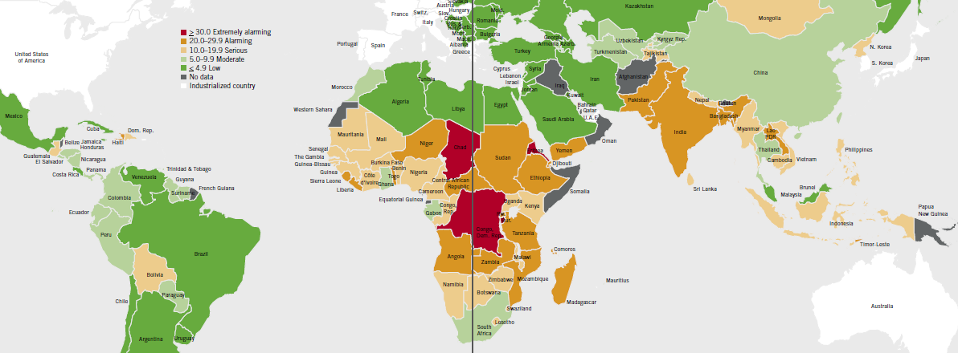
Source: von Grebmer et al. 2011.
Note: “Hunger” measured by the composite Global Hunger Index.
Large successes in agricultural development and food and nutrition security enhancement have been country-driven. Agricultural reforms in China and Vietnam, the Green Revolution in Asia, and the recent surge in agricultural production and productivity in Africa—induced by increased investment in agriculture—are some select examples. The success of country-owned and country-led processes hinges on a combination of good policies, increased agricultural investments, technological innovations, strong institutions, and good governance. This paper focuses on country-led innovations, agrifood value chains, reduction in postharvest losses and food waste, as well as on related capacities that are needed in developing countries.
Figure 2: Level of absolute poverty in the world, by country
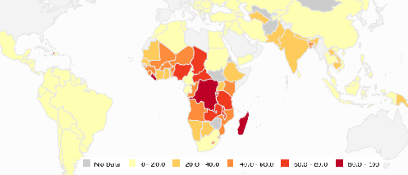
Source: World Bank, 2012.
Note: “Absolute poverty” measured by the share of population living on less than US$1.25 (PPP) a day.

Investment and innovations
Increasing agricultural investments and setting-right priorities are essential to broad-based growth and poverty reduction, as in many developing countries the agricultural sector accounts for a large share of national income and employment, and poverty continues to be a largely rural phenomenon. Research has shown that spending on agriculture represents a “win-win” strategy for development as it supports both growth and poverty reduction (Table 1). The Comprehensive Africa Agriculture Development Programme (CAADP), which is supported by IFPRI, is one program that promotes evidence-based policies and agricultural investments and has made considerable progress over the last few years.

Investment and innovation also have to address growing resource constraints. Among other approaches, more efficient input and resource use can be achieved through improved storage, processing, and marketing facilities that reduce postharvest losses, through water conservation efforts, as well as through breeding crop varieties that are resistant to droughts and pests. In the case of the latter, innovations in biotechnology have the potential to increase crop productivity, nutritional impact, and environmental sustainability without the significant use of additional—and potentially harmful—inputs.

Given the need to mitigate and adapt to climate change, technological innovations should also aim at transforming agriculture into a low-carbon sector. This includes land-management practices—such as mixed cropping, cover crops, and integrated farming—that can optimize crop productivity while limiting greenhouse gas (GHG) emissions. In this context, new approaches are also needed to help measure, track, and map GHG emissions in order to better target and monitor the mitigation potential of agriculture.
Cross-sectoral impacts such as the contribution of rural roads and telecommunication (ICT) to agricultural productivity need to be exploited, too, and other development outcomes, such as nutrition and health cannot be neglected, either. In particular, ICTs can provide farmers with valuable information such as market prices and weather forecasts, and they can facilitate farmers’ access to much needed financial services. Ultimately, the exact priorities depend on country-specific needs, capacities, and resources. In addition, to reduce the poor’s vulnerability to shocks, countries also need to expand and better target their social protection systems. Integrated programs, like Ethiopia’s Productive Safety Net Programme (PSNP), can tackle rural poverty by linking initiatives and helping poor farmers and herders build up assets and improve their productivity. Research has shown that households that benefitted from the PSNP (in combination with other social security programs) had a 10 percent higher mean caloric availability than comparison groups, and their credit use as well as their fertilizer use was 12 and 10 percentage points higher, respectively. Moreover, these households were almost 7 percent more likely to operate their own nonfarm businesses (Gilligan, Hoddinott, and Taffesse 2008).
Table 1: Public investment impact in a sample of developing countries
 | Ghana | Uganda | Tanzania | Ethiopia | China | India | Thailand
Sector | Returns to agriculture or rural income (local currency/local currency spending)
Agriculture | 16.8 | 12.4 | 12.5 | 0.14 | 6.8 | 13.5 | 12.6
Education | -0.2 | 7.2 | 9.0 | 0.56 | 2.2 | 1.4 | 2.1
Health | 1.3 | 0.9 | n.e. | -0.03 | n.e. | 0.8 | n.e.
Roads | 8.8 | 2.7 | 9.1 | 4.22 | 1.7 | 5.3 | 0.9
 | Ranking in returns to poverty reduction
Agriculture | n.e. | 1 | 2 | n.e. | 2 | 2 | 1
Education | n.e. | 3 | 1 | n.e. | 1 | 3 | 3
Health | n.e. | 4 | n.e. | n.e. | n.e. | 4 | n.e.
Roads | n.e. | 2 | 3 | n.e. | 3 | 1 | 2

Source: Fan, 2011.

Agrifood value chains
Over the past years a value chain approach to development—ranging from inputs supply, extension, market services, financing, production, processing, and distribution to marketing (Figure 3)—has increasingly been adopted by governments, donors, nongovernmental organizations, and development initiatives to promote market-oriented growth, and to reduce rural poverty in developing countries. At the same time agrifood value chains in developing countries are changing rapidly as these countries’ populations grow, get richer, and become more urban, with supermarkets, distribution, wholesaling firms, processors, and agro-exporters expanding and changing the marketing channels in which smallholders participate both as farmers and as consumers (Humphrey and Navas-Alemán 2010; Gómez et al. 2011).

Given that market failures often prevail, the value chain approach may not always be beneficial for all farmers, and so before taking action, policymakers should consider potential winners and losers in each case. Companies tend to contract with larger farmers first, and source from smallholders only where these dominate production—and then their preference is farmers with certain nonland assets, such as irrigation or access to paved roads. Yet, if deemed expedient, companies use “resource-provision contracts” to address credit, input, or extension constraints, which can help smallholders (Reardon et al. 2009).
Figure 3: Representation of a food supply chain
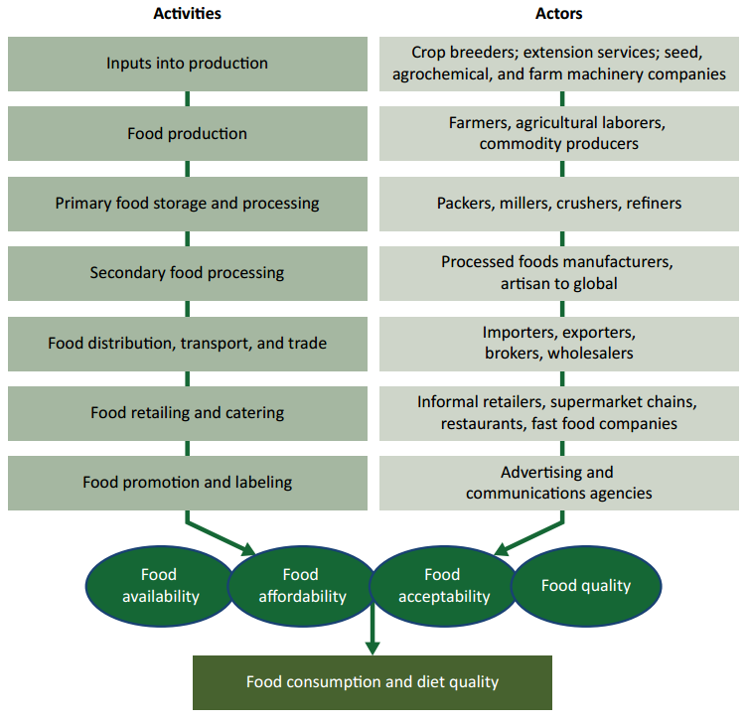
Source: Hawkes and Ruel, 2011.

The lessons of selected studies by IFPRI authors or affiliated researchers are summarized in Table 2. Apart from addressing input and infrastructure constraints, collective action by producers, public-private partnerships, and market deregulation are the measures that are most promising in helping integrate smallholders into agrifood value chains and in addressing other demands on modern food value chains, such as improving food quality and food safety, especially of perishable products.

To date, only a limited number of impact assessments have been carried out to analyze poverty alleviation through value chain interventions, and often it is unclear whether the interventions were responsible for observed improvements, whether the interventions benefited the poor disproportionately, or whether they were more cost-effective than alternative approaches. Since most empirical studies of the welfare effects of agricultural value chains have struggled to establish causality, it is therefore necessary to carry out additional analyses and systematic impact assessments at the program level to develop a stronger evidence base, and to explore long-term effects of smallholder participation in value chains (Humphrey and Navas-Alemán 2010).
Table 2: Agrifood value chains and smallholders
Authors | Focus | Product | Country | Beneficiaries, outcomes and impact | Obstacles and challenges
Saenger et al. (2012a, 2012b) | Contract farming | Dairy | Vietnam | Farmers: higher productivity. Processors: better milk quality with quality-dependent pricing, lower per-unit transaction costs with independent quality control. | Lacking incentive to invest in quality-improving inputs and to produce high quality milk when asymmetry of information is given, e.g., when opportunistic buyers can report lower than actual output quality, which negatively affects farmers’ compensation.
Hartmann (‘12) | Pro-poor chains | General | General | Poor farmers: poverty alleviation through integration into value chains. | Access to markets, elasticity of demand when supply increases, regulatory requirements, market interference, market failures, competition among targeted value chain actors.
Chenevix Trench et al. (‘11) | Food safety, food quality | Perishable food | General | Poor farmers: higher incomes from producing high-value food. Consumers: lower health risk. Labor: more employment. | Supply: low productivity, inadequate human and technical capacity, remote location, inability to comply with food safety requirements, lack of financial resources or credit to adopt prescribed procedures or invest in necessary equipment, lack of recognition as producers of safe food, cost of certification, limited competitiveness vis-à-vis larger growers, economies of scale in ensuring food safety, lack of information on good agricultural practices and the use of pesticides, late payments by retailers. Demand: affordability of food safety attributes, awareness of health risks of unsafe food.
Hawkes & Ruel (‘11) | Improved nutrition | Micronutrient-rich food | General | Poor and marginal populations: Better nutrition through more available, affordable and acceptable food that is more nutritious. | Intersectoral barriers that create disincentives to closer cooperation between sectors, lack of knowledge about what influences demand for nutritious food, focus on quick fixes to address nutrition problems, trade-offs between economic returns and nutritional benefits of agriculture, affordability of value-added products.
Reardon & Minten (‘11) | Structural transformation | Food crops | India | Farmers: higher farm prices. Urban consumers: greater food security. Labor: more employment. | Asset poverty, incl. collective assets (such as infrastructure) and individual assets (such as education, tubewells, credit access) in poorer areas and strata, restrictions on foreign direct investment in modern retailing, slow liberalization of wholesale markets, limits on private-sector procurement, storage, and sales to traders, regulatory and fiscal uncertainty, transaction costs.
Bernard & Spielman (‘09) | Producer cooperatives | Grains | Ethiopia | Smallholders: positive spillovers from cooperative activities. | Concentration of decisionmaking in management committees that are less inclusive of poor members, trade-off between inclusive membership, participatory decisionmaking, and marketing performance.
Cunningham (‘09) | National commodity development boards | Dairy | India | Small farmers and landless producers: access to markets and higher incomes. Urban consumers: more and better dairy products. Labor: female employment. | Lacking systems for procuring milk produced in rural areas, difficult and expensive transport of perishable products, adhoc marketing of milk, lack of private sector confidence in dairying, lack of program funding.
Source: Author’s compilation; sources hyperlinked via authors’ names.

Postharvest losses and food waste
One particular concern with current agrifood supply chains is the amount of food that is lost or wasted between farmers’ fields and consumers’ plates. According to the FAO this is roughly one-third of the global food production; the World Wildlife Fund (WWF) and others report estimates for current postharvest losses of 20–50 percent. In industrialized countries the main problem is food waste: for instance, calculations for the United States show that food worth more than 1400 kcal per person per day is wasted, accounting for more than one-quarter of the total freshwater consumption and about 300 million barrels of oil each year (Hall et al. 2009). In developing countries the biggest problem is food losses—which are caused by poor infrastructure, low levels of technology, and low investment in the food production systems, and which occur in the production, harvest, postharvest, and processing phases. Weeds, pathogens, and animal pests alone can cause crop losses of 26–40 percent; in Nigeria, 10–20 percent of the total production of grains and tubers is lost due to poor storage alone (Oerke 2006; Phillip et al. 2009). According to the World Bank, in all of Sub-Saharan Africa the value of postharvest grain losses amounts to US$4 billion a year—or as much food as could feed 48 million people.

Losses in the production phase occur through biotic and abiotic stresses, such as diseases, pests, and droughts. To reduce these losses, for instance, more stress-resistant crops can be developed, whether through conventional breeding, as in the case of fungi-resistant wheat, or through genetic engineering, as in the case of insect-resistant crops. Farmers can also pursue a crop diversification strategy where they replace local varieties with more drought-tolerant varieties, or they can adopt improved cultivation practices—a process that can be enhanced by the build-up of social capital.

Once harvested, the crops become part of the agrifood supply chain, and there the challenge for food scientists is to find solutions to reducing postharvest losses at various supply-chain stages (Figure 4). One emerging technology that may present new opportunities to improve food security and the livelihoods of the poor—by increasing productivity, reducing postharvest loss, improving product quality, increasing the competitiveness of agricultural producers, and improving market access—is nanotechnology.

More generally, to avoid losses in developing countries, the agrifood supply chain needs to be strengthened, which requires investments in infrastructure and transportation, as well as in food and packaging industries, with both the public and private sectors playing a role. In richer countries poor coordination along the supply chain, exaggerated quality and aesthetic standards, and the relatively low cost of foodstuffs contribute to large amounts of loss and wastage. There are promising signs that investments and human resource capacity in public agricultural research and development (R&D) are picking up in a number of developing countries—even if so far this is achieving little more than compensating for the neglect of the past decades. Similarly there is an increasing interest and commitment from the private sector to engage in the agrifood supply chain in developing countries, and private-sector innovation and research have already shown to be important sources of new agricultural technology in Sub-Saharan Africa—when and where they were facilitated through conducive government policies.

Strengthening the agrifood supply chain in developing countries can have wider benefits. For instance when a more stable and sufficient supply of produce of the right quality allows food processing factories to operate reliably and profitably, it reduces the dependence of low-income countries on imported food products and thereby improves their foreign exchange reserves while providing employment and development opportunities in poor rural areas. Furthermore, reducing wastage is a key element in increasing resource-use efficiency, one of the tenets of the green economy, as such efforts may streamline agrifood supply chains and reduce unnecessary use of energy, water, fertilizer, and land.
Figure 4: Losses along the food chain
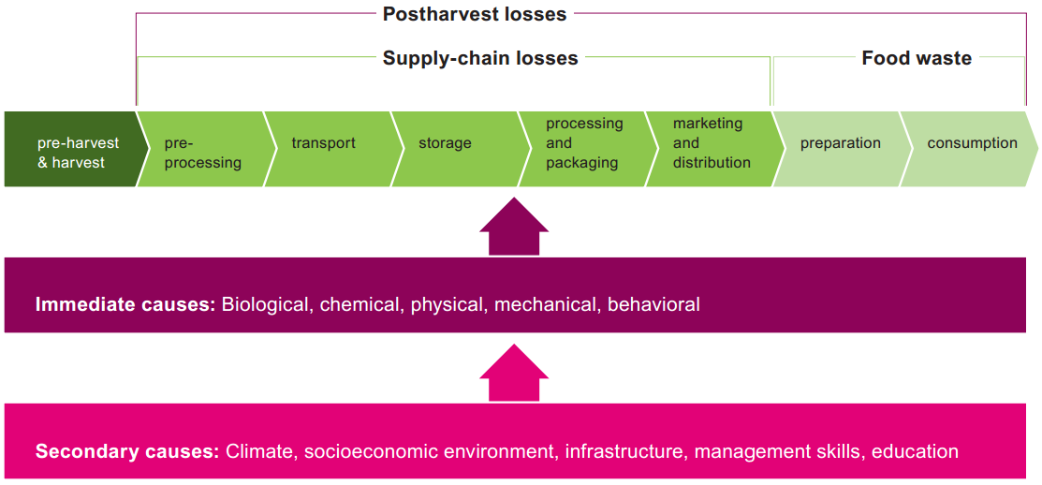
Source: Grethe, Dembélé, and Duman, 2011.

An emerging issue with negative consequences for postharvest losses and the agrifood supply chain is climate change. For instance, climatic fluctuations can favor the growth of mycotoxins, and more frequent extreme weather events can damage infrastructure such as warehouses and roads.

In-country capacities and scaling up successes
To speed up progress in the fight against hunger and poverty, a smarter, more innovative, better focused, and cost-effective approach is needed:
- First, the international community and developing countries themselves have to invest in agricultural research and extension, rural development, and targeted social protection, as these investments have large positive impacts on agricultural productivity, poverty alleviation, and production capacity.
- Second, new actors in global development, such as the private sector and in particular the food industry, have important roles to play in reducing hunger in developing countries. Given the right incentives and a conducive business environment, companies can provide effective and sustainable investment and innovation to upgrade local agrifood supply chains.
- Third, to be more effective, efficient, and sustainable, as well as better adapted to the local context, in many cases policies have to be country-led. Similarly, to be more inclusive and to increase “ownership,” reforms have to build on bottom-up support, with local people acting as a driving force in the development process.
- Fourth, to improve the success rate of reforms, successful pilot projects and policy experiments need to be scaled up and unsuccessful policy options have to be eliminated. To generate the evidence needed for these decisions, policymakers need to allow impartial monitoring of these activities and to apply the lessons learned by adjusting their policies.
- Fifth, decisionmakers at all levels have to stand by their commitments to policies and investments for enhancing food security, not only by ensuring the disbursement of pledged funds, but also by supporting them with institutions, governance, and monitoring.

Some such approaches have already been successful in a few countries, but they need to be scaled up and extended to additional countries to have a real impact on the reduction of global hunger and poverty. To support developing-country governments and their partners in identifying areas for agricultural and rural investment and policy interventions, IFPRI established a “Strategic Analysis and Knowledge Support System” (SAKSS) to act as a network for governments, donors, research institutes, universities, the private sector, and nongovernmental organizations in Africa. To this end, SAKSS compiles, analyzes, and disseminates data, information, and tools that help better design, implement, and evaluate agriculture and rural development strategies. By having IFPRI’s in-country strategy support programs implement SAKSS, capacity building in the target countries is not neglected, which is another important element for successful country-owned and country-led approaches for reducing hunger and poverty.

Conclusions
Despite progress, so far less than half of all developing countries have a reasonable chance of meeting the Millennium Development Goal (MDG) of halving hunger by 2015, compared to the proportion of hungry people in 1990, at least if measured by the proportion of underweight children. Neither is the developing world on track to achieving the MDG of halving the 1990 poverty rate—if China is excluded (Stevens et al. 2012; Chen and Ravallion 2012). This is an alarming development and it clearly shows that more and continued efforts are required by global, national, and local actors to reduce hunger and poverty.

More and sustained investment in agriculture is one of the best bets in the fight against hunger and poverty, but related fields like rural infrastructure, as well as nutrition and health in developing countries, also need to receive more funding. Technological innovations in food and agriculture that increase productivity and reduce losses—and that are compatible with the needs of smallholders—have to be promoted. In this context, the increasing interest of the private sector in engaging in developing countries can facilitate the expansion of the agrifood value chain and formal markets, and it can help in the development and dissemination of innovations. Government policies that strengthen the position of smallholders should support their integration into the agrifood value chain, which will be facilitated where their productivity and access to rural infrastructures is improved. Further down the value chain, food science and technology in particular can help reduce food losses and increase resource-use efficiency.

However, sound evidence is needed to determine which strategies, technologies, investments, institutions, and partnerships should be scaled up in-country to achieve enduring impact on hunger and poverty. Therefore a framework—and an open mindset by decisionmakers—for evaluating pilot projects and experiments in developing countries is needed, as is a political and legal space to transform the lessons learned into large-scale initiatives. To this end stakeholders at all levels and from all sectors need to work together.

References

Fan, S. 2011. “New Approaches to Food Security.” Paper presented at the annual meeting of the New Champions of the World Economic Forum, Dalian, China, September 14–16. http://dgcorner.ifpri.info/2011/10/06/new-approaches-to-food-security/

Gilligan, D.O., J. Hoddinott, and A.S. Taffesse. 2008. “The Impact of Ethiopia's Productive Safety Net Programme and its Linkages.” IFPRI Discussion Paper 839. Washington, DC: IFPRI. www.ifpri.org/publication/impact-ethiopias-productive-safety-net-programme-and-its-linkages

Gómez, M.I., C.B. Barrett, L.E. Buck, H. De Groote, S. Ferris, H.O. Gao, E. McCullough et al. 2011. “Research Principles for Developing Country Food Value Chains.” Science 332: 1154-1155. http://dx.doi.org/10.1126/science.1202543

Grethe, H., A. Dembélé, and N. Duman. 2011. “How to Feed the World’s Growing Billions.” Berlin: Heinrich Böll Foundation, WWF Deutschland. www.boell.de/publications/publications-study-how-to-feed-the-worlds-growing-billions-fao-12032.html

Hall, K.D., J. Guo, M. Dore, and C.C. Chow. 2009. “The Progressive Increase of Food Waste in America and Its Environmental Impact.” PLoS ONE 4: e7940. http://dx.doi.org/10.1371/journal.pone.0007940

Hawkes, C., and M. Ruel. 2011. “Value Chains for Nutrition.” 2020 Conference Paper 4. Washington, DC: IFPRI. www.ifpri.org/publication/value-chains-nutrition

Humphrey, J., and L. Navas-Alemán. 2010. “Value Chains, Donor Interventions and Poverty Reduction.” IDS Research Reports 2010(63): 1–106. http://dx.doi.org/10.1111/j.2040-0217.2010.00063_2.x

Oerke, E.-C. 2006. “Crop Losses to Pests.” Journal of Agricultural Science 144: 31–43. http://dx.doi.org/10.1017/S0021859605005708;

Phillip, D., E. Nkonya, J. Pender & O.A. Oni. 2009. “Constraints to Increasing Agricultural Productivity in Nigeria.” NSSP Working Paper 6. Washington, DC: IFPRI. www.ifpri.org/publication/constraints-increasing-agricultural-productivity-nigeria-0

Reardon, T., C.B. Barrett, J.A. Berdegué, and J.F.M. Swinnen. 2009. “Agrifood Industry Transformation and Small Farmers in Developing Countries.” World Development 37: 1717–1727. http://dx.doi.org/10.1016/j.worlddev.2008.08.023

Stevens, G.A., M.M. Finucane, C.J. Paciorek, S.R. Flaxman, R.A. White, A.J. Donner, and M. Ezzati. 2012. “Trends in Mild, Moderate, and Severe Stunting and Underweight, and Progress Towards MDG-1.” Lancet, online July 4. http://dx.doi.org/10.1016/S0140-6736(12)60647-3.

Chen, S., and M. Ravallion. 2012. “More Relatively-poor People in a Less Absolutely-poor World.” Policy Research Working Paper WPS-6114. Washington, DC: World Bank. http://go.worldbank.org/H2IK32TVU0

von Grebmer, K., M. Torero, T. Olofinbiyi, H. Fritschel, D. Wiesmann, Y. Yohannes, L. Schofield, and C. von Oppeln. 2011. 2011 Global Hunger Index—The Challenge of Hunger: Taming Price Spikes and Excessive Food Price Volatility. Bonn, Washington, DC, Dublin: Welthungerhilfe, IFPRI, Concern Worldwide. http://dx.doi.org/10.2499/9780896299344ENGHI2011

World Bank. 2012. “Poverty & Equity Data.” Website, accessed June 18. Washington, DC: World Bank. http://povertydata.worldbank.org/poverty/home

